1. Popular social question-and-answer website - >Quota

Found Norman Flyn (https://www.quora.com/profile/Norman-Flyn/)

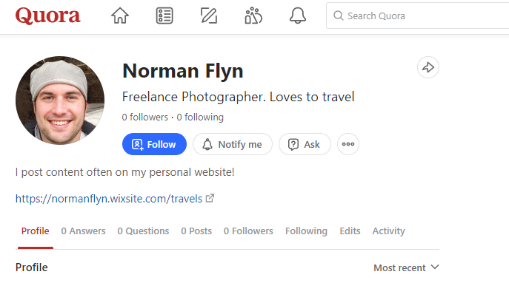

1. Visit his personal site (<https://normanflyn.wixsite.com/travels>)

Explore the page & under contacts we find his twitter account.

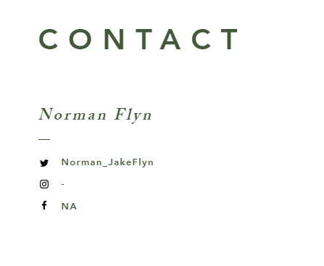

1. Check out his Twitter account (<https://twitter.com/Norman_JakeFlyn>)

Several mentions of @FlynDiary_bot:

* On his posts (<https://twitter.com/Norman_JakeFlyn/status/1431961218084864000>)
* Follower mention (<https://twitter.com/Norman_JakeFlyn/status/1432016717144739853>)

1. Found @FlynDiary_bot on telegram.

/help to see available options

/ViewDiary -> American photo and video social network service @norman_jake_flyn

/flag -> does nothing

/getCurrentLocation -> plus code for 50 Nanyang Ave, #32 Block N4 #02a, Singapore 639798

*Notice it is in plus code*

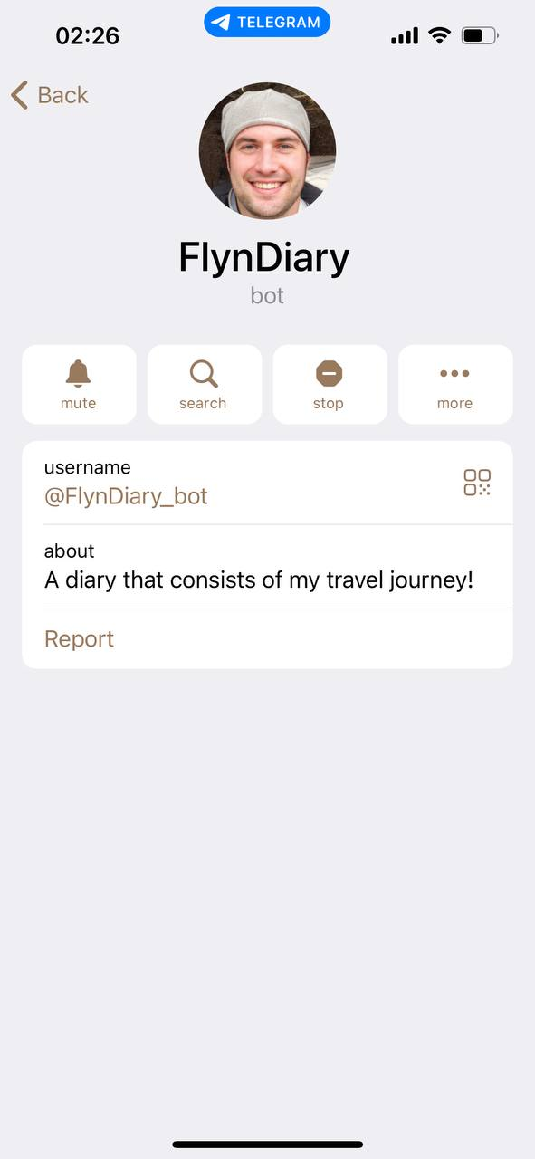 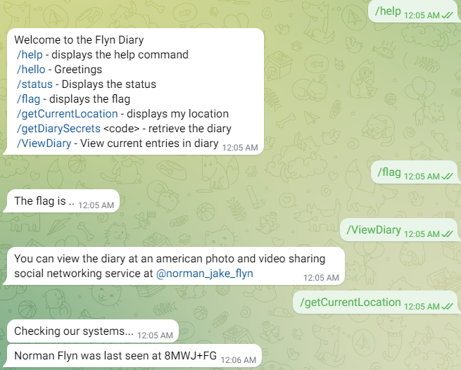

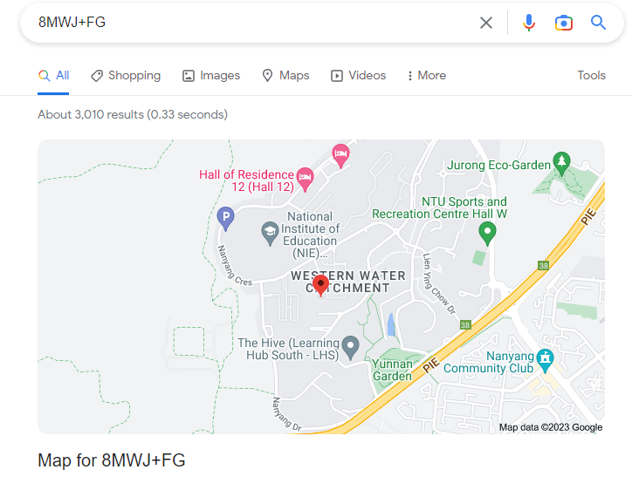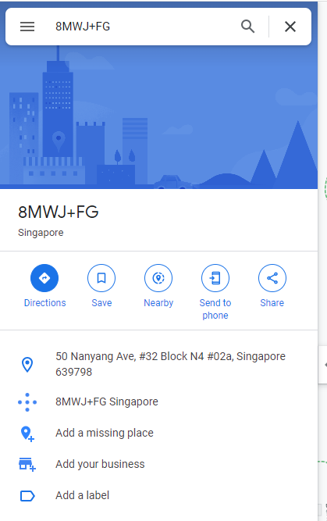

1. Found @norman_jake_flyn on Instagram.

One of his posts contains a link to his location.

<https://www.picturemosaics.com/photo-mosaic-tool/share/id/M9009844/p/p4>

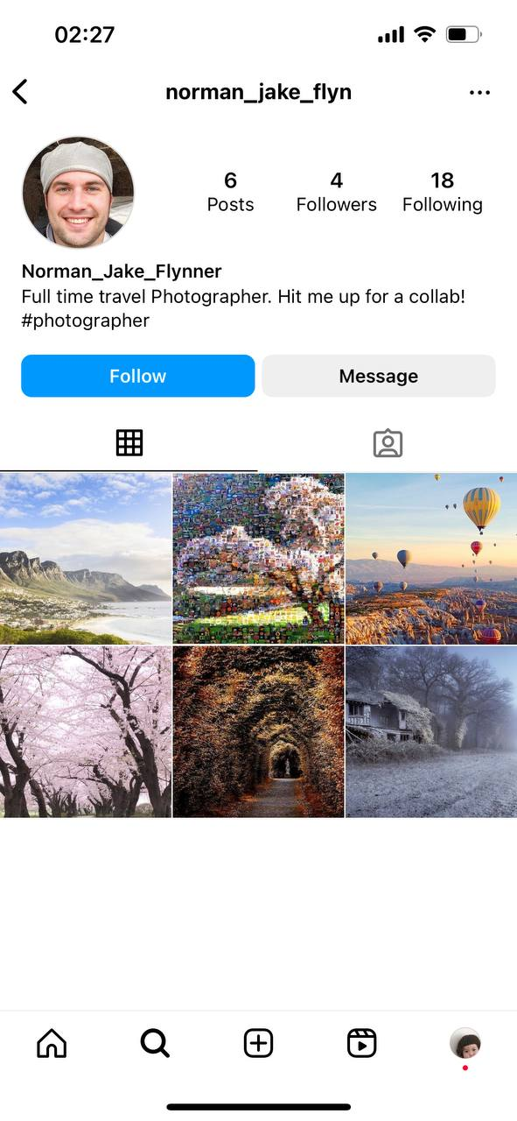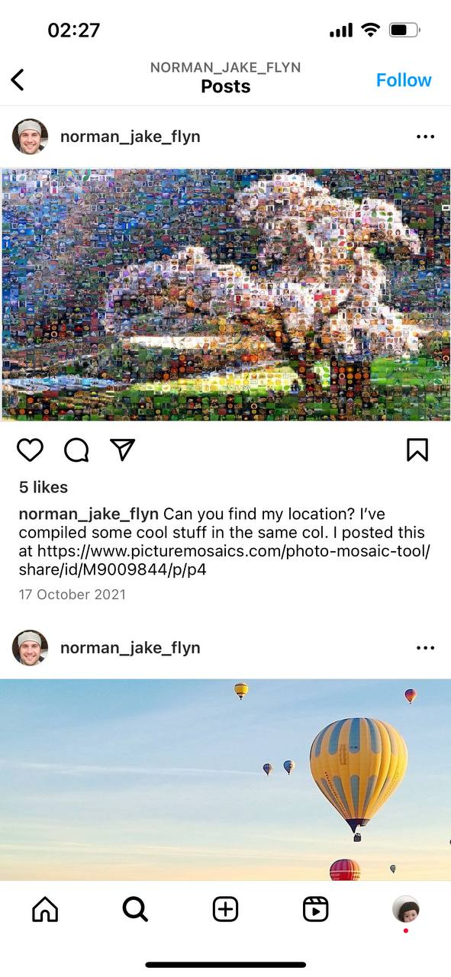

1. Head to the picturemosaics link

Found some cool stuff in the same column (circle in red)



* First, we found a screenshot of the google maps of NTU, inclusive of pulse code 8MWJ+FG
* Next, in the same column, we notice an image which supposedly look like a map leading to the destination that could give us the code needed for /getDiarySecrets

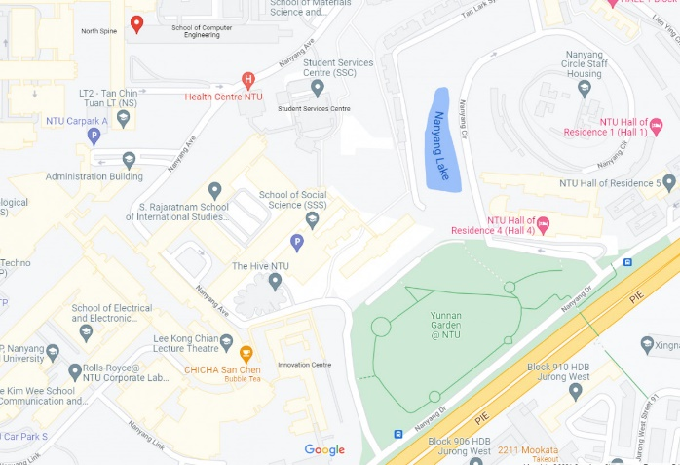

If we start from 8MWJ+FG and follow the traced route, our destination will be Yunnan Garden

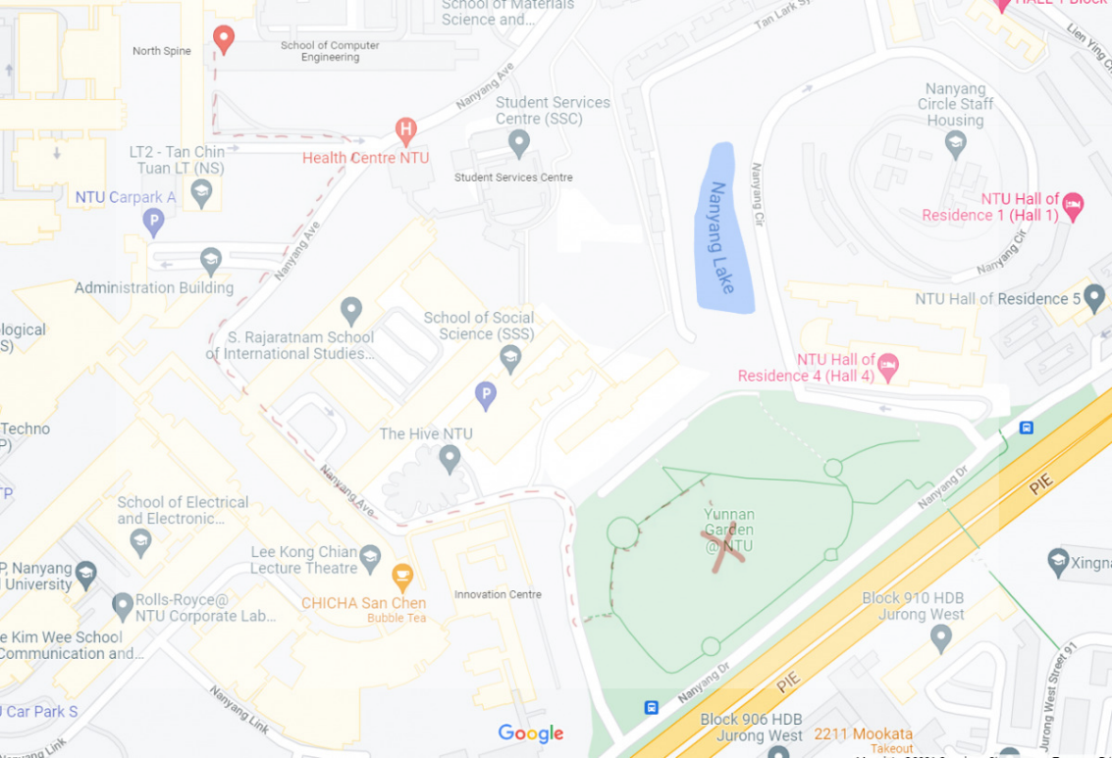

Look for Yunnan Garden on Google and submit it’s pulse code (8MVM+5W) as code for /getDiarySecrets

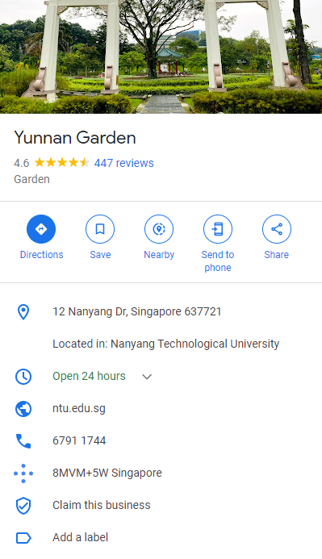

1. Submit Yunnan Garden pulse code to get Flag

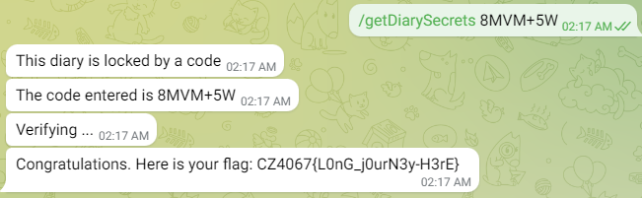

Flag : CZ4067{L0nG_j0urN3y-H3rE}